**Task No 3**

**C++ Programming**

**Name: Hamna Jahangir**

**Date: July 20,2024**

**Code:**

#include <iostream>

#include <fstream>

#include <string>

using namespace std;

// Function to compress the file using RLE

void compressFile(const string &inputFileName, const string &outputFileName) {

ifstream inputFile(inputFileName, ios::binary);

if (!inputFile.is_open()) {

cerr << "Could not open the input file." << endl;

return;

}

ofstream outputFile(outputFileName, ios::binary);

if (!outputFile.is_open()) {

cerr << "Could not open the output file." << endl;

inputFile.close();

return;

}

char currentChar, previousChar;

int count = 0;

inputFile.get(previousChar);

count = 1;

while (inputFile.get(currentChar)) {

if (currentChar == previousChar) {

count++;

} else {

outputFile << previousChar << count;

previousChar = currentChar;

count = 1;

}

}

// Write the last set of characters

outputFile << previousChar << count;

inputFile.close();

outputFile.close();

}

// Function to decompress the file using RLE

void decompressFile(const string &inputFileName, const string &outputFileName) {

ifstream inputFile(inputFileName, ios::binary);

if (!inputFile.is_open()) {

cerr << "Could not open the input file." << endl;

return;

}

ofstream outputFile(outputFileName, ios::binary);

if (!outputFile.is_open()) {

cerr << "Could not open the output file." << endl;

inputFile.close();

return;

}

char ch;

int count;

while (inputFile.get(ch)) {

inputFile >> count;

outputFile << string(count, ch);

}

inputFile.close();

outputFile.close();

}

int main(int argc, char *argv[]) {

if (argc != 4) {

cerr << "Usage: " << argv[0] << " <c/d> <inputfile> <outputfile>" << endl;

cerr << "c - Compress" << endl;

cerr << "d - Decompress" << endl;

return 1;

}

string mode = argv[1];

string inputFileName = argv[2];

string outputFileName = argv[3];

if (mode == "c") {

compressFile(inputFileName, outputFileName);

} else if (mode == "d") {

decompressFile(inputFileName, outputFileName);

} else {

cerr << "Invalid mode. Use 'c' for compression and 'd' for decompression." << endl;

return 1;

}

return 0;

}

**Output:**

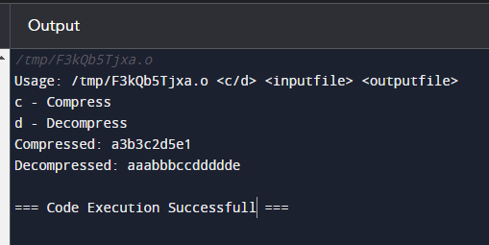

**Github link:**

**<https://github.com/Hamna-123739/DEP-Python-programming>**

**Linkedln link:**

**<https://www.linkedin.com/in/hamna-jahangir-51b3a9311?utm_source=share&utm_campaign=share_via&utm_content=profile&utm_medium=android_app>**